EXPT NO:5 | DASHBOARD DESIGNING
DATE: 24.01.2026 | DASHBOARD DESIGNING

PRE-LAB QUESTIONS

1. How do dashboards support strategic decision-making?
Dashboards convert raw data into visual KPIs that allow decision-makers to quickly identify trends, risks, and performance gaps. This enables faster, data-driven strategic actions instead of relying on intuition.

2. What role do dashboards play in AI monitoring systems?
Dashboards act as real-time monitoring interfaces for AI systems, displaying predictions, anomalies, and performance metrics so humans can validate, intervene, or optimize AI decisions.

3. Why is interactivity essential in modern dashboards?
Interactivity allows users to filter, drill down, and explore specific subsets of data, improving insight discovery and preventing one-size-fits-all analysis.

4. What cognitive overload issues exist in dashboards?
Overloading dashboards with excessive visuals, colors, or KPIs reduces clarity, increases confusion, and slows decision-making.

5. How are KPIs derived from raw data?
KPIs are created by aggregating, summarizing, and transforming raw data into measurable indicators aligned with organizational goals.
OBJECTIVE: To design an interactive analytical dashboard for monitoring key metrics.
SCENARIO: An AI-based smart campus system requires a dashboard to monitor attendance, academic performance, and resource utilization in real time.
IN-LAB TASKS (Using PowerBI)
• Design KPI cards for attendance and performance
• Implement filters by department and semester
• Link multiple views for drill-down analysis

OUTPUT:
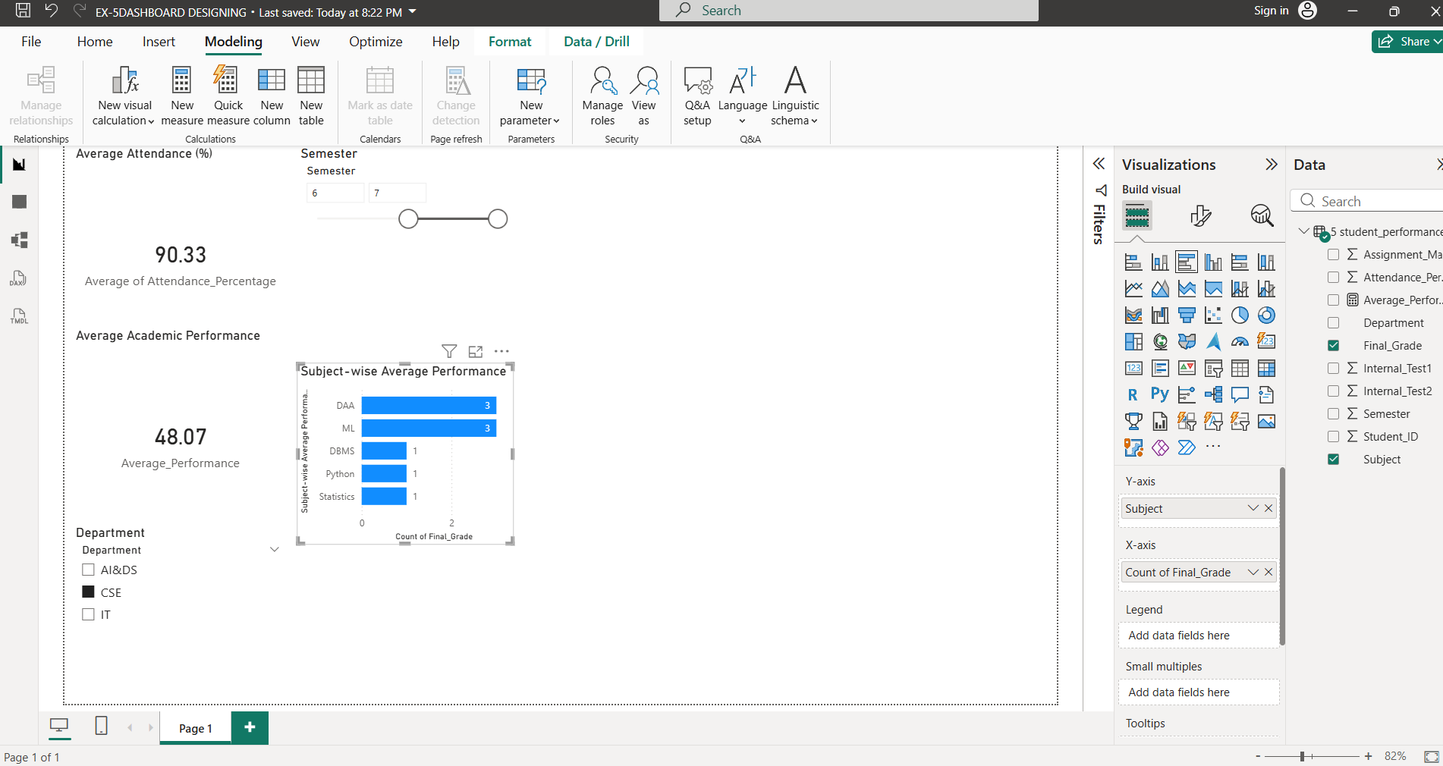

Gitlink: https://github.com/Shamini-tech/23BAD109_U18AII5202_/tree/main/EX-5DASHBOARD%20DESIGNING

POST-LAB QUESTIONS

1. How does interactivity improve analytical depth?
Interactivity enables users to explore specific dimensions of data, uncover hidden patterns, and perform focused analysis rather than static observation.

2. Which KPIs are critical for academic monitoring?
Attendance rate, average academic performance, pass percentage, and departmental performance trends.

3. What design principles prevent information overload?
Minimal visuals, consistent color schemes, limited KPIs per view, and clear labeling.

4. How can dashboards be integrated with AI alerts?
AI models can trigger alerts based on anomalies or predictions, which are visualized in dashboards for immediate action.

5. How do dashboards enhance transparency in institutions?
They provide stakeholders with clear, real-time access to institutional performance data, promoting accountability and trust.

ASSESSMENT
Description | Max Marks | Marks Awarded
Pre Lab Exercise | 5
In Lab Exercise | 10
Post Lab Exercise | 5
Viva | 10
Total | 30
Faculty Signature

